**Project Design Phase-II**

**Technology Stack (Architecture & Stack)**

|  |  |
| --- | --- |
| Date | 11 November 2022 |
| Team ID | PNT2022TMID42456 |
| Project Name | Project – Personal expense tracker |
| Maximum Marks | 4 Marks |

**Technical Architecture:**

The Deliverable shall include the architectural diagram as below and the information as per the table1 & table 2

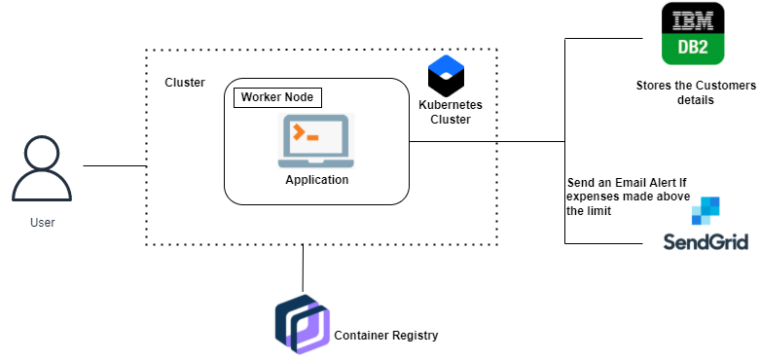

Guidelines:

1. Include all the processes (As an application logic / Technology Block)
2. Provide infrastructural demarcation (Local / Cloud)
3. Indicate external interfaces (third party API’s etc.)
4. Indicate Data Storage components / services
5. Indicate interface to machine learning models (if applicable)

**Table-1 : Components & Technologies:**

|  |  |  |  |
| --- | --- | --- | --- |
| **S.No** | **Component** | **Description** | **Technology** |
|  | User Interface | The user interacts with the application through Mobile App, Chatbot. | Flask, HTML, CSS, JavaScript |
|  | Application Logic-1 | Logic for a process in the application is written using python language. | Python |
|  | Application Logic-2 | To covert speech to text in the chatbot. | IBM Watson STT service |
|  | Application Logic-3 | To build conversational interfaces into the app. | IBM Watson Assistant |
|  | Database | The data’s are collected and stored in container registry. | MySQL |
|  | Cloud Database | The IBM cloud object storage service is used to store dataset in cloud. | IBM DB2 |
|  | File Storage | The coding written and the images are stored in the file. | Container registry |
|  | External API-1 | To receive email notification. | Sendgrid API |
|  | External API-2 | Two factor authentication and secured authorizations. | Authy API |
|  | Infrastructure (Server / Cloud) | Application Deployment on Local System / Cloud  Local Server Configuration:  Cloud Server Configuration : IBM cloud service | Local, Cloud Foundry, Kubernetes. |

**Table-2: Application Characteristics:**

| **S.No** | **Characteristics** | **Description** | **Technology** |
| --- | --- | --- | --- |
|  | Open-Source Frameworks | Sendgrid to receive an email alert when the amount exceeds the limit. | Python |
|  | Security Implementations | Data encryption, Access controls, Data validation, Remove unnecessary information. | Access controls, Encryptions |
|  | Scalable Architecture | Micro services architecture is built as suite of small services, each with its code base. | Python |
|  | Availability | The application is available all the time, there is no time constraint. | IBM Cloud |
|  | Performance | As the application is deployed in IBM cloud it can handle upto 1,00,000 requests per second. | IBM Cloudant technology |